**D1 – Explain how the processor is physically connected to memory and Input/output (I/O) devices using the system buses**

**Introduction**

In this report, I will be explaining how the processor is connected to the memory and the I/O devices using the system buses. I will use diagrams to explain this.

**Explain**

**Bus**

A bus, in computing terms, is referred to a set of wires that connect any independent components of the system, so they can pass signals between the two of them. There is not only one of bus, as you can see below; they are many of them. Each of the bus have different jobs and I am going to be explaining what each of them are going to be doing.

**Data Bus**

Data bus is designed to control the data. They are wires that make up these buses and these wires are the width of the bus. Data bus consists of 32 wires and these wires can be connected with two or more components within the computer. These wires are used to send information between the two. In this case, this bus will send data. Referring to the image below, data bus can send information between each of the components. For example, Input/output can transfer data between the two with memory using data bus. If I were to send data to another computer, within this system, data bus can send it from I/O to memory.

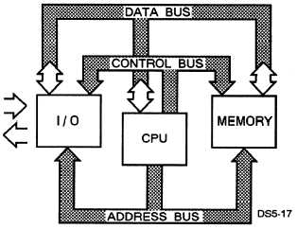

**Address Bus**

Address bus is similar to ‘data’ bus, but does the total opposite. This bus delivers the destination that the user requires. This means, if I were to send an email to my teacher, it would travel from I/O to its destination. This has 32 wires, same as data bus. The picture above shows how the address bus works. It gets the picture, email or whatever it needs to send to another person and it locates it by the IP address and sends it. It is simple the way it works.

**Control Bus**

Control bus, consisting of eight wires, that sends signals between the components that it is connected with. All of these buses work together. The address bus carries on information on, and the data bus carries on the actual data and the control bus carries command from the CPU, and the information that is received, it is send to the other buses for the specific data to be send to the target.

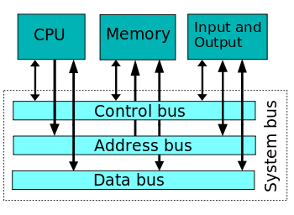

**System Bus**

System bus is a single bus that connects all the buses, which are named above, are all together. This seems unnecessary, but it is used to reduce cost. The picture shows how a system bus is. All these arrows are buses that communicate with the components within the computer.

**Processor**

A processor is a microchip imbedded into the CPU’s hard drive that manages all the programmes. It is known as the, “brains of the computer”. The processor holds instructions, which is given to the programmers. They are different types of processors: INTEL and AMD. For example, INTEL has different types such as Intel i3, i5, i7. Intel i7 has four cores. The speed of this is 3.5GHz. The cache is 6MB. Obviously, each of the Intel processors named, they have different speed and cores. They have an electrical path that allows communicate between other components.

**I/O maps**

An ‘I/O’ stands for Input/Output. I/O maps is a process between a processor and a peripheral. An I/O mapped is assigned to one or more of the processor’s I/O maps and they transfer information between the processor and peripheral using the input and output instructions. This means, they send it when a user sends an input. For example, clicks the program to close, the expectation is to close the program. They do this by using the I/O maps and communicating between the processor and the peripheral.

**How it works?**

This works by the device that is used. For example, if I were to be using a mouse, the CPU would send instructions to move the mouse. The CPU gives commands for the I/O to work.

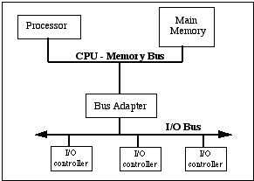 **How the processor is physically connected with the memory?**

The way it works is by the CPU using bus to exchange data between the two. The bus adapter is used to communicate the two, processor; memory and I/O, together. It sends signals between the two to enable communication. Varieties of jobs are done between these. Referring to the figure 1.1, it show it works between them. They all communicate with each other.

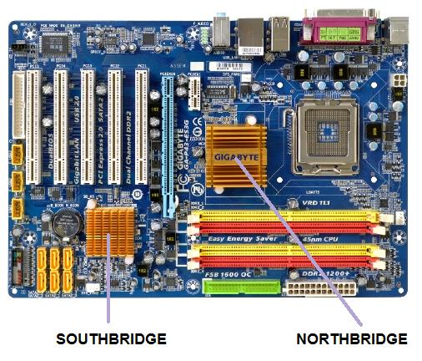They are only two chipsets on the motherboard, one being Northbridge and the other Southbridge. A chipset is important for the motherboard. This is a set of electrical components on the motherboard, which manages the data flow of the memory, processor andperipherals. As you can see on the motherboard below, the Northbridge and Southbridge is present. Unlike Southbridge, Northbridge acts like a “bridge” and it is directly connected to the CPU. Therefore, the Northbridge is connected to the CPU, RAM, AGP and Southbridge. Southbridge has no connection to the CPU. For information to reach to Southbridge, it must be passed through Northbridge to reach to Southbridge. Updated computers have more than one chipset on their computer. As you can see on the image, the Northbridge is slightly bigger than Southbridge. Of course, the upgraded versions are much better. They can be both into one chip. This is used on the motherboard, and the purpose of using this is it channels information to the CPU, so that it can be processed. The old systems use this way. The way they use is that everything is connected through the Northbridge chip. An example of where this is used is the AMD.

**How a printer prints paper?**

The first most important part is for the printer to be linked with the computer, and for it to be on and ready to print. It is essential that it is connected, otherwise it would not print the paper. The instruction needs to be set. The user needs to send instructions to the printer for it to print. For example, click print on whatever you want to print. Once that is done, the instructions are sent to the printer. The printer gives feedback to the computer if anything is wrong with the printer, e.g. paper runs out. If it has run out, the user will need to put more paper in. Once the status is fully functioning, checked by the CPU, it will print the document. Polling is used in this case. Polling checks the status for any external device. This is a clear example. The I/O prints the document, polling checks the status, instructions are sent to the CPU for it to be printed, and it prints the paper. Communication has to be enabled for this to work.